Acceptance Test for Create input text field for sequence User Story
The user opens the main GUI.
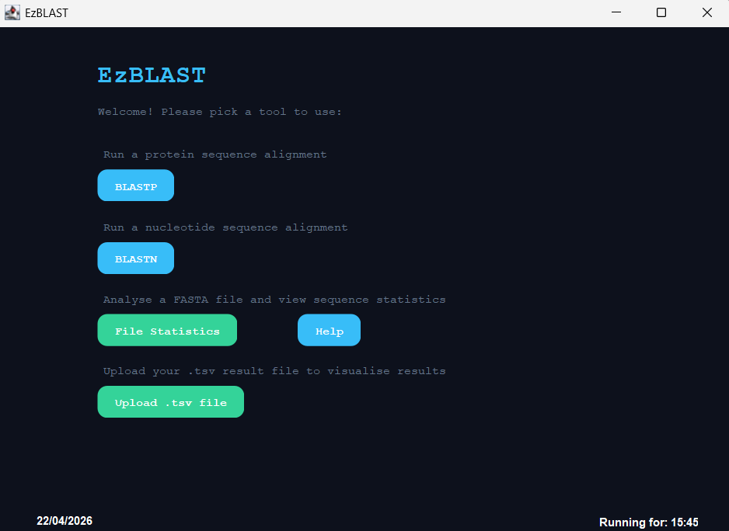
The navigates to BLAST and types in their query sequence in the text field.
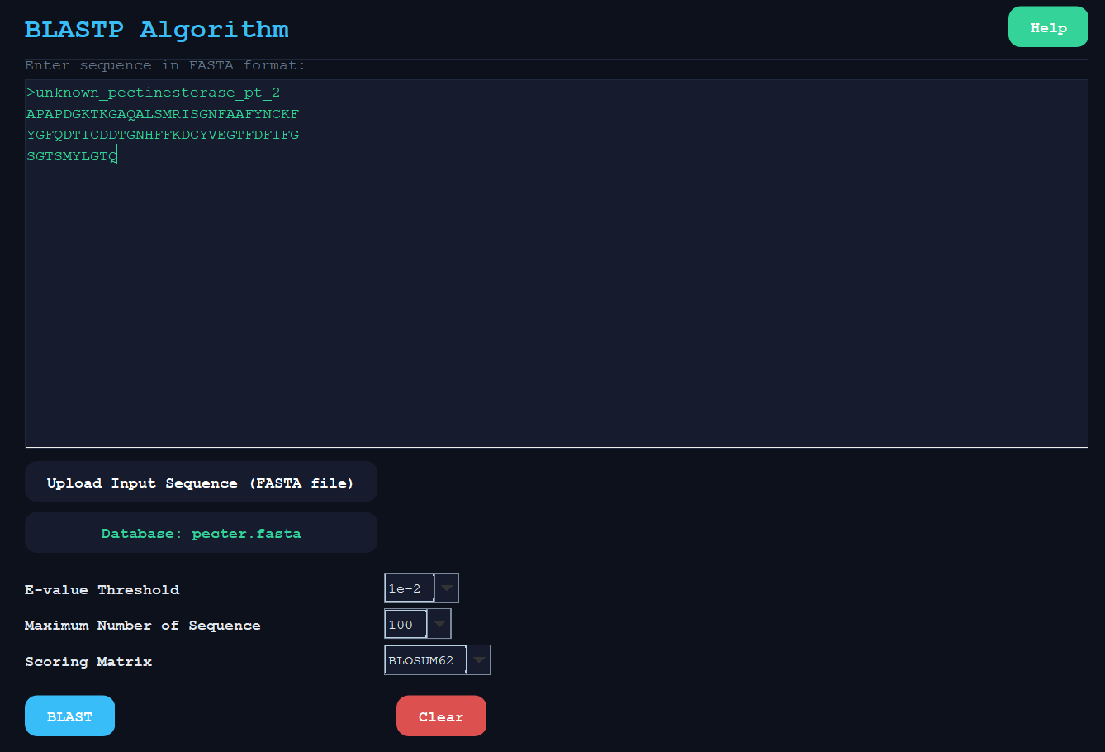

The user runs BLAST and an output is created with information about the matching sequences.
